**User Manual**

GenomePro 2.0 is a web application for processing genomic data files. The application runs online and can be found on this internet address: http://genomepro.cis.fiu.edu

The following are brief, yet descriptive steps on how to successfully use the application.

**Step 1: Accessing the Application**

Access the internet in your mobile, desktop or laptop device using your preferred internet browser.

**1**  **2** 

In the URL address bar of your browser type: **http://genomepro.cis.fiu.edu**

**Step 2: Accessing the Home Page**

Once you have accessed the web site you should see the home page:



You can scroll down to see more information about GenomePro 2.0 and navigate through the other pages: About and Contact. It is necessary to open an account with GenomePro in order to see and use the genomic data processing framework.

**Step 3: Registering**

You can register by clicking on the Register button which will redirect you to the registration page where you can create a new account. After creating a new account you will need to confirm your email address by visiting your email and clicking on the link for account confirmation sent by GenomePro administrator.

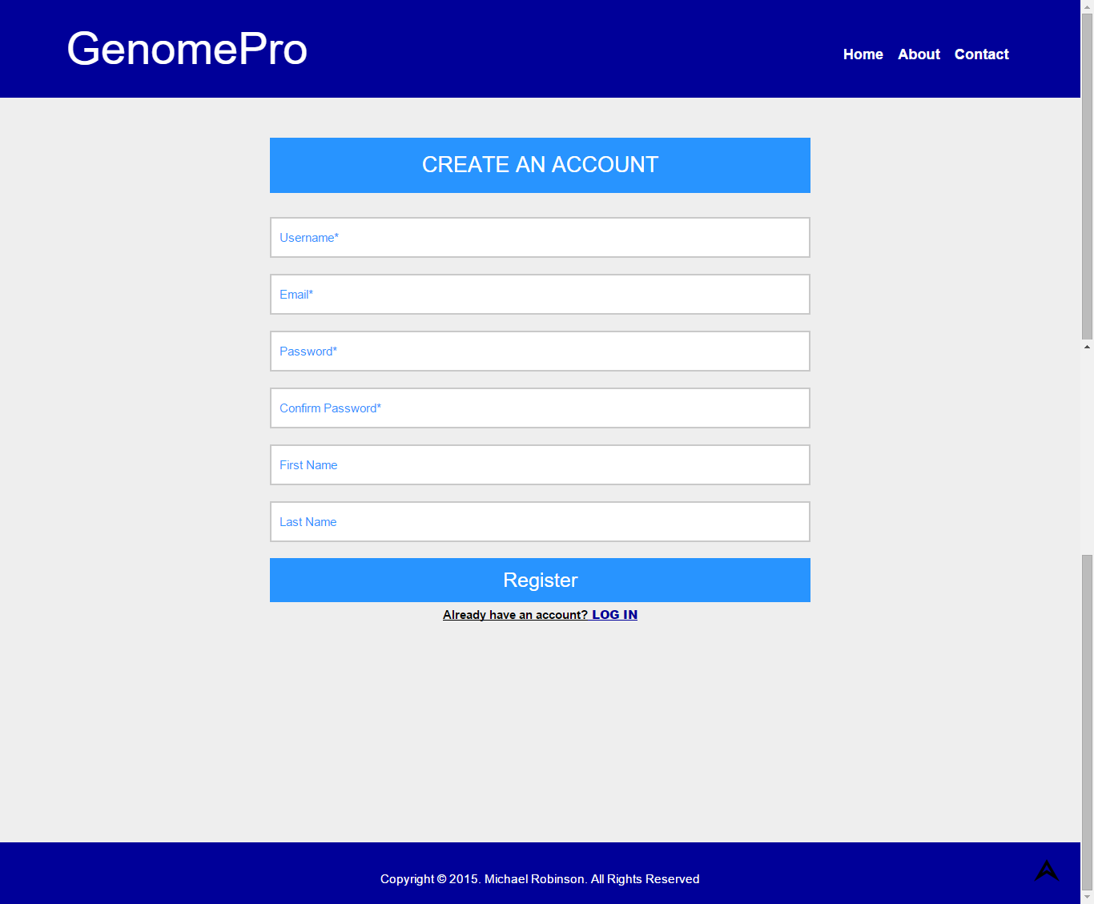

**Step 4: Logging In**

Once you have registered and confirmed your email, you can go back to the home page and enter your credentials in the login section on the left hand side of the page which will take you to a page that looks like this one:



Navigate through the pages and you can see that now you have access to more pages: Profile, Tools, Charts and FTP pages.

**Step 5: Editing your Profile**

You can edit you profile by clicking on the profile link and changing your personal information

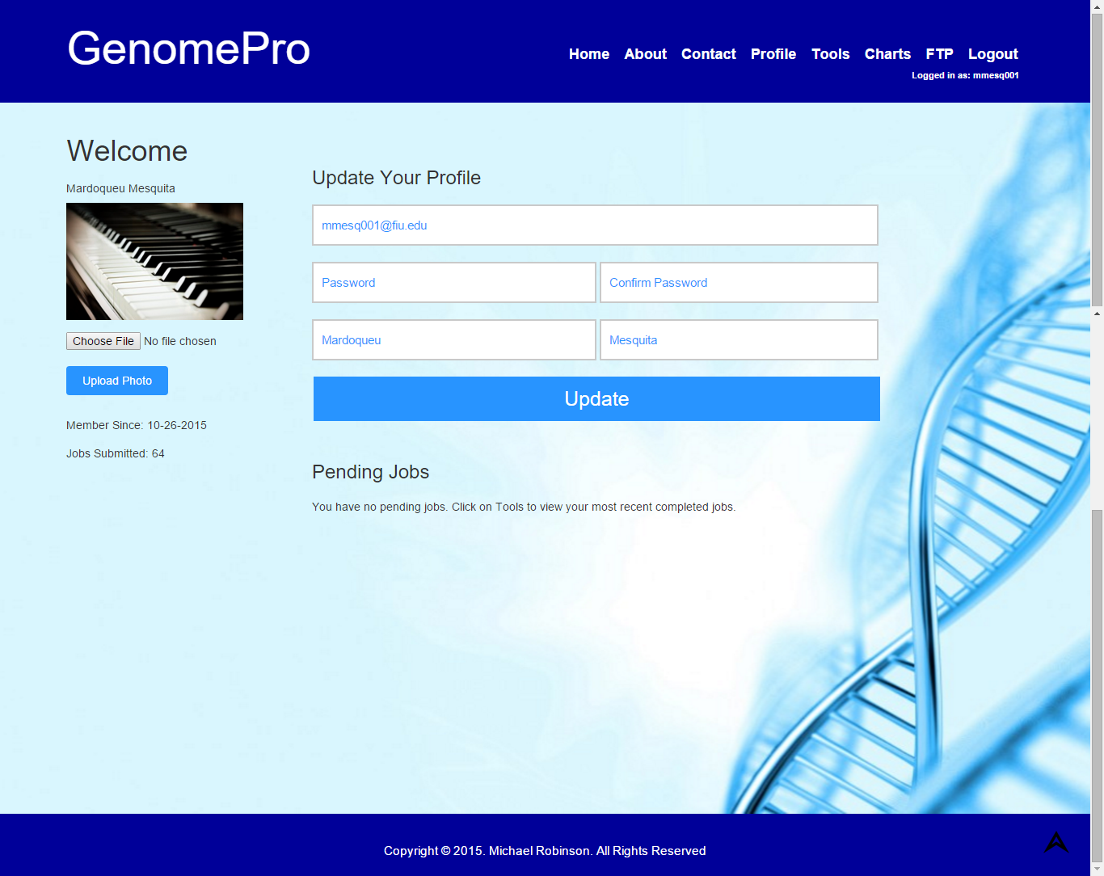

The system will automatically send you an **email confirmation** to the email you provided notifying you of the changes you made.

**Step 6: Contacting the Administrator**

You can also contact GenomePro administrator about questions and concerns or any other type of information you would like to share by clicking on the contact page.

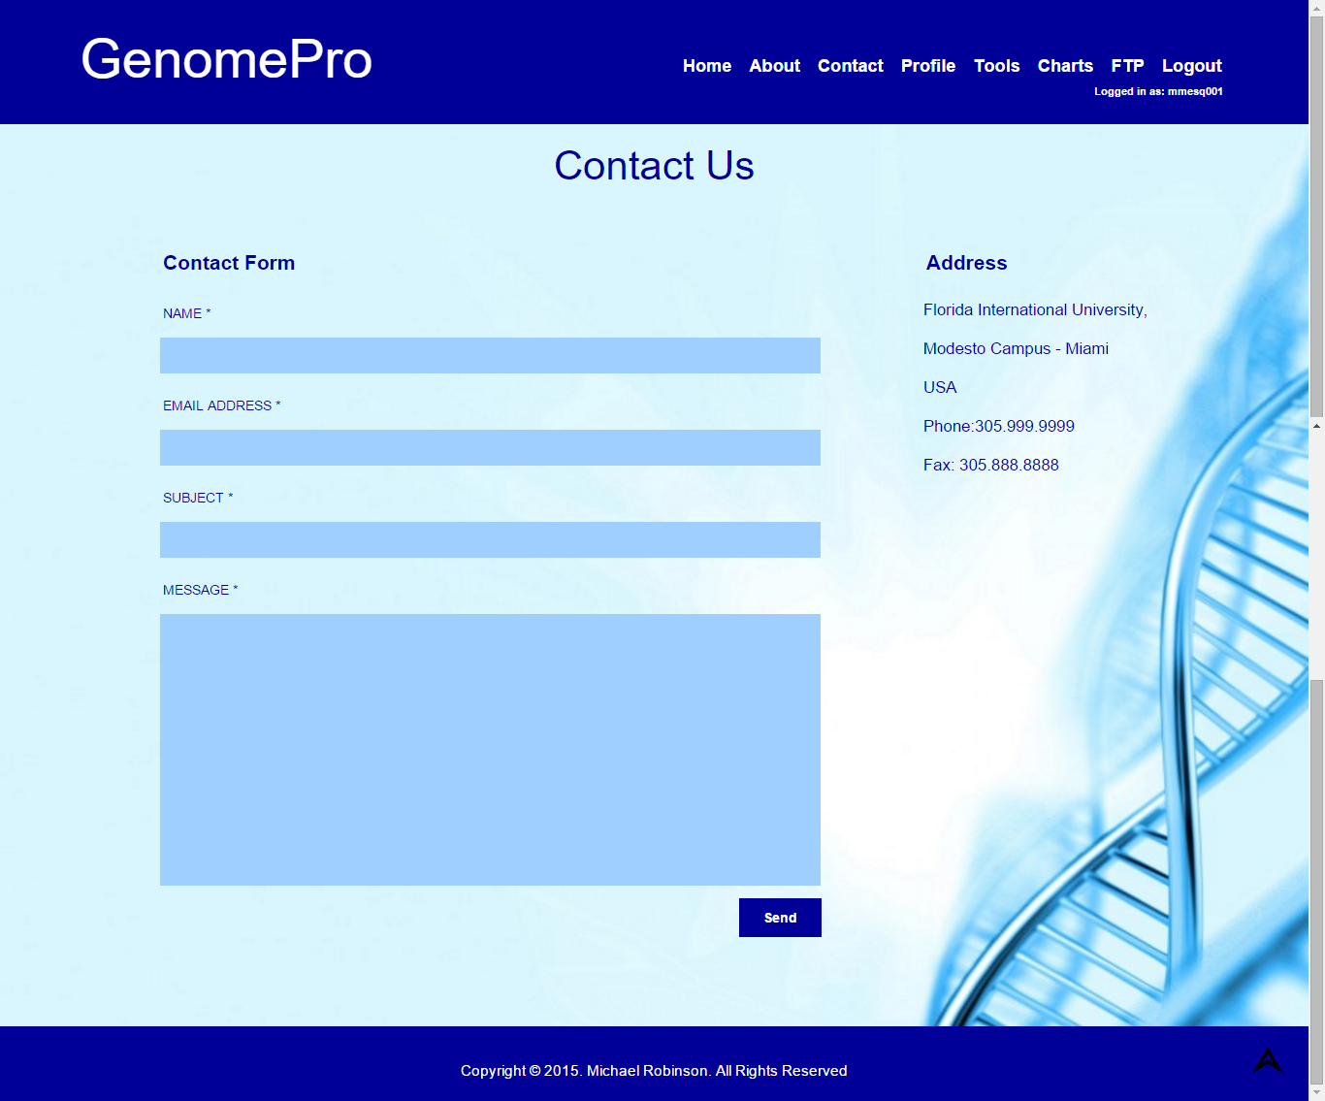

The contact form is very straightforward. **All the fields are required**: Name, email address, subject and message.

**Step 7: Using the Tools**

Click on the tools link to access the tools page. The first step to start using the tools is to upload files into your account so that you can use them for processing the tools. When uploading a file, it will be sent to server for validation. You will be notified via email when the file has been validated and if it is ready to be used. The file validator is a program that verifies whether you have submitted a good file (DNA, RNA or Protein) or a bad file (any other unsupported file type). The program will automatically detect what type of file you submitted and group them accordingly to their types. In other words, if you submitted a DNA file, it will be grouped in the DNA tab. If you don’t know the data type of your genome file, simple upload it to the server and the validator will verify this information for you.

After you have uploaded your files, you can submit jobs using single tool for single files or multiple tools for multiple files. For example, if you want to clean your FASTA or FASTQ file, you can check the Extract Fasta/Fastq tool and select a file from the file selection boxes. You will notice that a rectangle now appears bellow the file selection box for you to enter the length of the sub-sequences you would like to be extracted from your file. More information about how to use each tool can be found in the tools description and tools helper section at the bottom of the tools page. After selecting a file, if you later decide that it is not the file you would like to use for the selected tool, simply click on the clear file selection button to deselect the file.

Some tools such as the extract tool, generates result files such as sorted sequences and maps that will be later grouped in the map tabs for you to use to create charts or as input for other tools.

On the left side of the tools page you will also find a box where your job submissions are saved in the order they were submitted – from most recent to the oldest. By clicking on the Job ID you will be redirect to your results page containing information about your job submission.

Tools Page

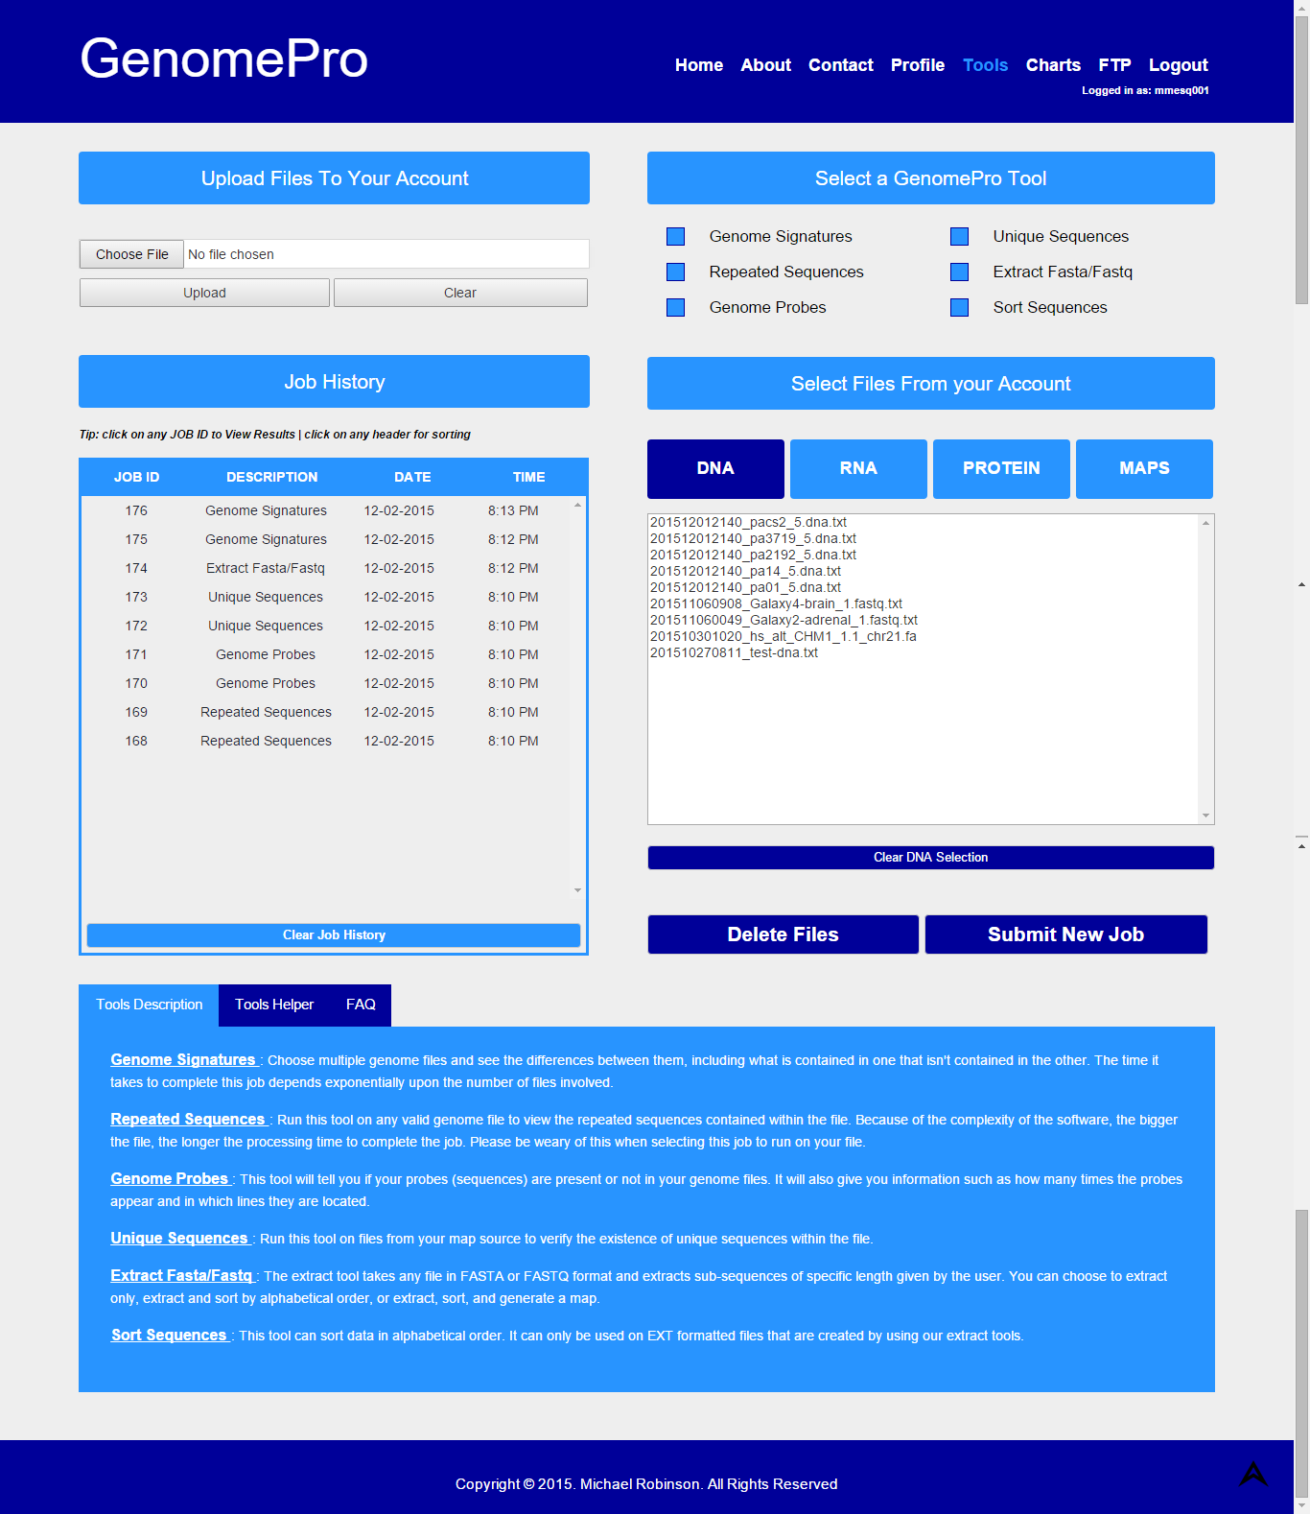

**Step 8: Generating Charts**

Click on the charts link to access the Charts Page. This feature is to create charts from map files that were generated from the extract and sort tools. In this page you will see a sample chart on the right side to exemplify what you will get as a graphic visualization of the sequences from your genome file. Each dot in the graph represents a sequence. The X-axis contains the locations where the sequences are repeated in the genome file.

To generate charts simple choose a map file from the first selection box and the desired sub-sequences from that map file that you want to be displayed in the chart. Click Create Charts button to generate the chart. After generating your chart, you can also zoom in a specific area of the chart by drawing a square/rectangle area with your mouse over the chart are so that you can visualize the sequences in a better way. On the top right hand corner you have the options to download the chart in PDF, JPG, PNG or even print the chart.

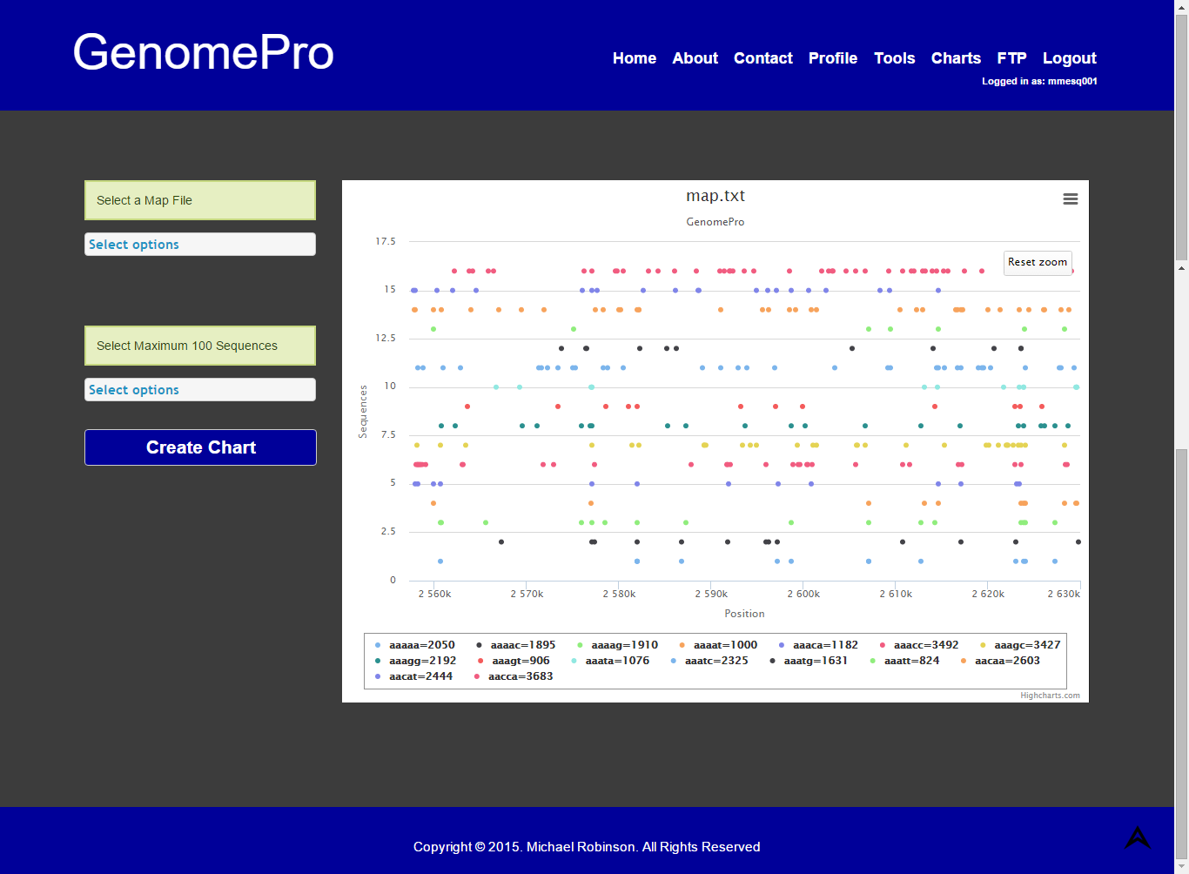

**Step 9: Navigating your FTP page**

Click on the FTP button to access the FTP page. This page contains information about all your uploaded files as well as your result files and jobs submitted. As an added layer of security, you will be asked to enter your credentials to access this page. Enter the same username and password used for logging into the site.

If you click on the Uploads Folder, you will have access to the Details folder which contains information about your uploaded files such as how many bases it has and the corresponding percentages of each base in relation to the entire file. This is the folder you want to look at and find out why any of your file might have been tagged as bad file (invalid file or unsupported type). Some examples of this situation are files that contain garbage data or empty files.

The results folder contains a list of all your job submissions with subfolders organized from the most recent job submission to the oldest ones.

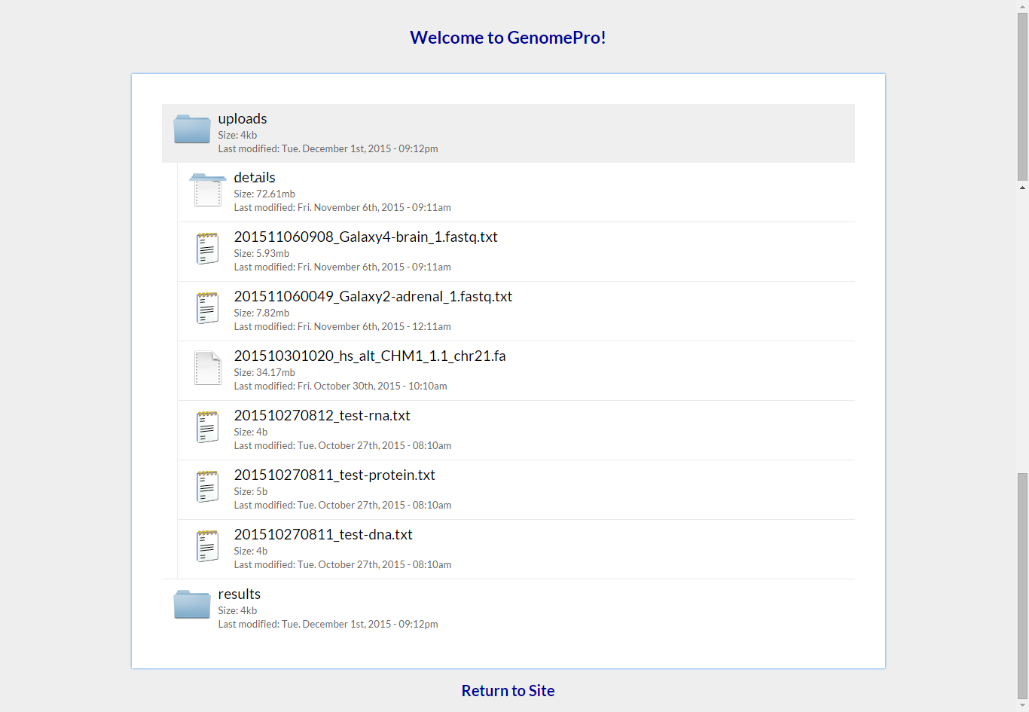

**Step 10: Resetting your password**

In case you forget your password, you can submit a temporary new password using the forget password feature. Click on the home page and click on the Forget Password link in the login.

A popup screen will appear asking you to input a valid registered email. Enter your email and click the Send Request button. You should receive an email with your new temporary password. We recommend that you change your temporary password as soon as possible.

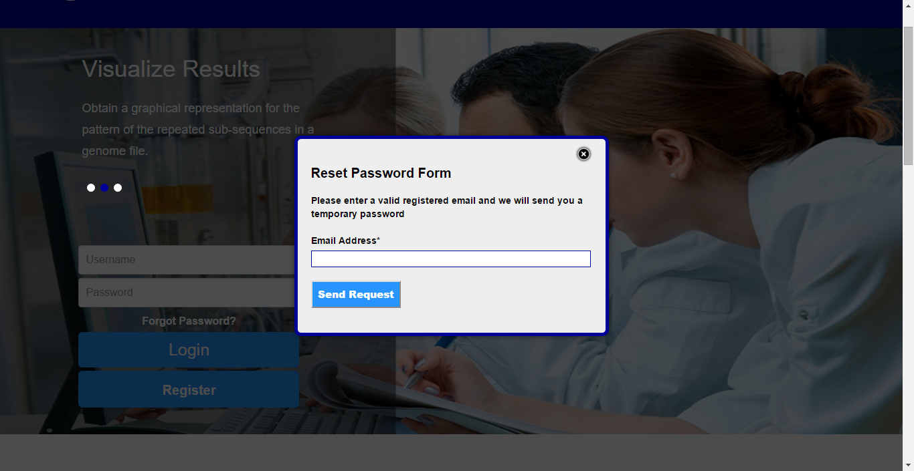

**Step 10: Logging Out**

If your account is left inactive for long period of time, it will be logged out of the system, as an added security feature. You can always log out by clicking on the logout button on the top right hand corner of the page.

**Step 11: Questions and Concerns**

Contact the administrator using our contact form.